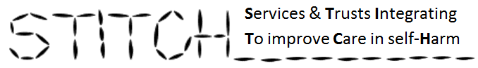
Annual Review January 2013-14
STITCH HIT Concept and Vision 
Suicide prevention is a national priority. Self harm is the highest risk predictor of future completed suicide. People who self harm and their care and treatment spans across Bristol health and social care, both statutory and voluntary sectors. STITCH aims to examine the care pathway, ask staff and patients what helps them and utilise Bristol Health Partners knowledge, expertise and resources to enable us to achieve the highest quality evidence based patient focused care and treatment.

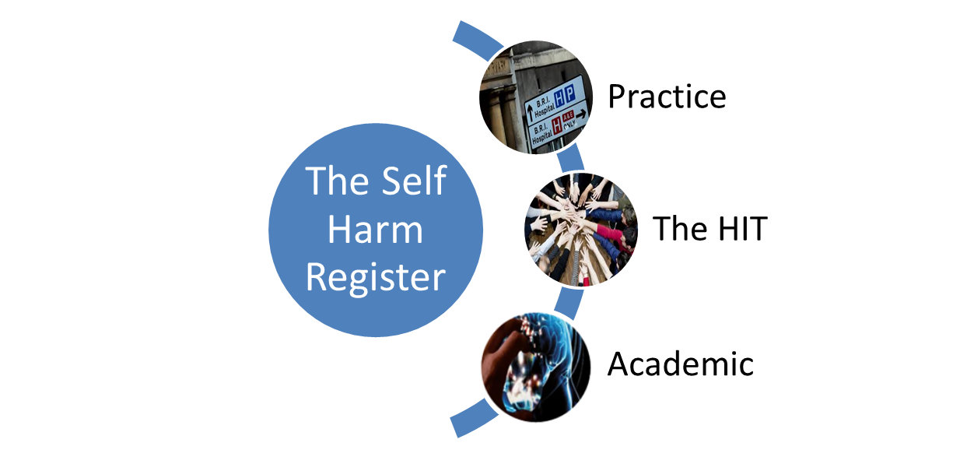

Aim
Our aim is ensure self harm treatment and care is equitable, fully evidence based and non-stigmatising for all people who self harm; and to reduce suicides in Bristol.

STITCH Partners
Salena Williams – HIT Director (UHB)
Lisa Galvani – STITCH Chair, Divisional Manager SHN UHBristol
David Gunnell – Research Lead (UoB)
Jonathan Benger – Research and ED Lead (UWE, UHB)
Lucy Griffin – Consultant Psychiatrist (AWP)
John Lovelock – Liaison nurse (NBT)
Christina Gray – Public Health Lead (BCC)
Catherine Wevill – Social Care (BCC)
Andrew Keefe - CSU Bristol N Somerset, S Gloucestershire
Rachel Clarke – IWG Link (AWP)
Anthony Harrison – Consultant Nurse (AWP)
Jenny Donovan – Research Advisor (UoB)
John Potokar – Liaison Psychiatrist (UoB)
Suzanne Pearson – Service user rep
Sarah Saunders – Service user
Lisa Wheatley – BHP Programme Manager
Mary Perkins – Exec Link (BHP)
Martyn Baxter – Non-stat services lead - Samaritans Director
Julliette Hughes – ED matron, Frenchay Hospital (NBT)
Claire Thompson - Clinical Commissioning Group

STITCH Objectives
http://www.bristolhealthpartners.org/health-integration-teams/current-hits/the-improving-care-in-self-harm-hit/

Lead Organisation
University Hospitals Bristol NHS Foundation Trust

HIT Team Partners
University of the West of England, Avon and Wiltshire Partnership NHS Trust, North Bristol Trust, NHS Bristol, Bristol City Council and University of Bristol

Introduction
Reducing suicide is a national priority; self-harm is the highest risk predictor of suicide and a major cause of death in Bristol. Self-harm is a growing problem for the NHS in Bristol and across the rest of the UK, with around 200,000 hospital emergency department cases reported nationally every year. The number of people who self-harm in Bristol alone is estimated at around 25,000. The condition is the highest predictor of suicide, with self-harm patients 35 per cent more likely to end their own lives.
Coming to hospital is the tip of the iceberg of distress and the key challenge is the range of different organisations involved in emergency care and aftercare there no clear trust ownership of the overall service for this vulnerable group of individuals; we aim to work with all partners on this key issue.

Hit Aims
80% Patients who have self harmed receive psychiatric assessment
>80% Emergency Staff trained in self harm
10% reduction in the incidence of repeat self-harm in Bristol
Reduced prescriptions of drugs with high lethality when taken in overdose
50% reduced admission to a hospital bed for self-harm
20% reduced admission to intensive care of self-harm patients
10% reduced length of stay in hospital if self harm patient admitted
20% reduction in suicides in Bristol by those who self harm
Quality objectives: reduce duplication, CQC/NICE compliance, patient satisfaction
Securing personnel to direct and support HIT

Key themes:
- Reducing rates of suicide in Bristol by improving care and support for people who self-harm
- Delivering an improved, research based coordinated level of care for people who self-harm

HIT expected benefits in 2013, year one:
Quality:
Enhanced patient experience of Bristol Healthcare
Greater Patient / carer / family engagement in care
Greater Patient and carer involvement in the creation / maintenance of services
Productivity:
Establishing a robust data collection System to itemize and understand the landscape and needs.
Evaluation of current provision to establish the most effective treatment options.
Innovation:
Emergency Department: UHBristol and North Bristol Trust use of experience based design to understand from the key stakeholders and how the service could be improved.
Organisations working together; service users and staff working together.
Explored new ways of promoting the work of the STITCH through Salena Williams’s appearance on Radio 4’s Woman’s hour (29th November 2013 www.bbc.co.uk/programmes/b007qlvb/episodes/player)
Prevention:
Utilising the Self harm database to understand Bristol overdose behaviour using prescribed medications.
Training GPs to prevent prescribing lethal medications in overdose lending to reduction in ITU admission.

STITCH: The First Year Achievements in 2013
- Creating a Bristol-wide self harm surveillance database to collate numerical activity and outcome data across three hospital sites (Bristol Royal Hospital for Children, Bristol Royal Infirmary and Frenchay Hospital).

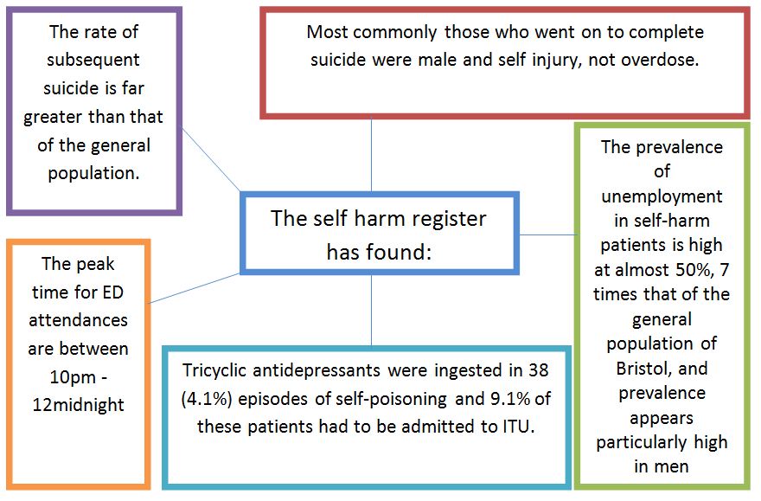

Further to the register being established NIHR research has been published:
Epidemiology, management and outcome of paracetamol poisoning in an inner city emergency department Carroll R¹, Benger J^{2,3}, Gibbard K⁴, Williams S⁴, Griffin L⁴, Potokar J^{1,4}, Gunnell D¹. (Emergency medicine Journal, 2013)

- Collating all national evidence and literature relating to good self harm care.
We found:
staff who had received training had more helpful attitudes towards self-harm patients
negative staff attitudes amongst A&E staff
emergency contact card was beneficial
beneficial effect of Cognitive Behavioural Therapy
Positive experiences of care were associated with greater participation in care and care decisions and the perception of staff as sympathetic
There is no clinical efficacy to risk screen tools in ED
Utilising data base evidence to look at trends and areas for improvement

- Standardising all self harm assessment documentation across Bristol sites. Both Frenchay liaison psychiatry and Bristol Royal Infirmary Liaison Psychiatry Teams use a standard, research based assessment proforma (with some local differences). This includes the use of the Becks Suicide Intent Scale which has research evidence of prediction of future risk.

- Setting in place the ability for service users to become involved in shaping the service. Bristol Self Injury Self help (SISH) Group engaged with the STITCH project to utilise patient expertise in surveys, questions and user involvement. We held Service user forums thoughout the year and invited feedback and the ability to become involved though a number of different avenues. The relationship remains and will be strengthened in year two of STITCH. Service user and carer consultation and feedback was also achieved through partnership with other voluntary sector organisations, and direct invitations. We created a specific young peoples network (the Self Injury Network Group – or SING) which continues to provide a network for self harm agencies.
- Evaluating Emergency Department care using ‘Experience Based Design’: a service redesign tool to collaborate with all emergency department stakeholders to evaluate the experience of the services.

We asked staff via:

Self Injury Self Help (SISH) created and individual patients/service users and relatives used:

Both staff and patients met and discussed their ideas in a joint event. All participants created a large action plan. Frenchay and BRI chose the short term and more in depth plans to work on and have started to make those changes.
Actions to be achieved:
Following the STITCH shared voices conference, the following actions were agreed to be taken forward: these are part of our 2014 planning:
Resource Pack
Agency self referral forms Phone numbers and helplines
Advance directives Domestic violence
Drug and alcohol Leaflets
Mission statement/care statement
Reception
Postcards Mental Health Notice board
Privacy form/Poster about stating ‘personal’ as reason for attendance
TV information programmes
Training for staff in ED
Induction all new ED staff including training on the matrix
Bite size live teaching Mental health champions in Department
Shadowing liaison psychiatry – 1-2 days Mental health Notice board in staff room
Training pack for all professionals in ED Training for volunteers in ED
Crisis Card
Hand held postcard size crisis card Personal plan: patient held
Repeat attendance plan
Add a question to the Cas card and matrix – have you got a careplan?
Other suggested changes
Policy in ED Mission statement for ED
On-going patient survey staff survey
carer evaluation GP letter
Debriefing for staff after incidents

- Distinct interventions in the Emergency Department to evaluate impact on care.
- Saturday Nurse pilot: understanding from the self harm register that many patients attend ‘out of hours’ and those patients were less likely to receive NICE guidance based care, we piloted a psychiatric nurse to work directly in ED on Saturdays. We evaluated this using the Register, and found reductions in wait times and reduction in admissions to hospital beds, with less patients going to mental health services also.
- ‘Did not wait’ postcards: a trial is currently underway to attempt to encourage self harm patients not to go home before treatment or psychosocial assessment. The intervention focusses on a postcard outlining how important it is to wait for in ED, and some helpline numbers in case the patient decides to leave. This has not been fully established or evaluated as yet.

- Teaching GPs: Evidence from the self harm register informed us about the number of patients attending ED/being admitted to hospital following overdose of prescription medication.
Most common recent medications taken in Bristol resulting in ITU admission from overdose (Figures from UHBristol May – June 2013):
Date | Drug | Amount taken
29/03/2013 | Ferrous fumerate | 1100mg
 | Venlafaxine | 4725mg
 | Paracetamol | 4000mg
 | Ceterizine | 800mg
 | Tramadol | 500mg
23/05/2013 | Tramadol | 3 months worth
 | Codiene | 3 months worth
 | Diazpeam | 3 months worth
22/05/2013 | Amitryptaline 50mg | 18
05/05/2013 | Quitiapine 300mg | 54
17/05/2013 | Amitryptaline 25mg | 84
23/05/2013 | Venlafaxine 150mg | 60
31/05/2013 | Moxonide | ?
04/06/2013 | Quitiapine | 20
- Other drugs taken for overdose during this period include Asprin, Perhopodine, Lansoprazole, Natrazepam, Sertraline, Slozem, Rivatil, Nicerondo and Rosuvastatin
We have undertaken a pilot teaching full day in April 2013, with robust qualitative recording of responses. In liaison with commissioners we have given training to over 100 GPs in Bristol and further training is planned. In 2014 we hope to look at IT systems across GP surgeries to alert GPs of self harm activity .

STITCH Developments into 2014:
Quarterly meetings of the STITCH Steering Group throughout 2014 will enshrine future planning of the project. Some of the plans for 2014 include:
- Ensure care improvement changes are consolidated in Emergency Departments at Frenchay and Bristol Royal Infirmary
- Follow progress of Business case for the self harm register and enhanced psychiatric liaison service to the Emergency Department
- Develop good practice and close communication with GPs and Emergency Departments
- Further research utilising the self harm register
For any further information, please contact: Salena Williams: Senior Nurse/Team Manager
Liaison Psychiatry, Bristol Royal Infirmary, Marlborough Street, Bristol BS2 8HW Tel: 0117 342 2777
E-mail: salena.williams@uhbristol.nhs.uk or http://www.bristolhealthpartners.org.uk/stitch

