Fourth Monday of the month
The South Bristol Alzheimer / Dementia Café
at
St Monica Trust
Monica Wills House,
Cromwell Street
Bedminster, BS3 3NH
2pm – 4pm

July 2016
This leaflet contains information about the South Bristol Alzheimer /Dementia Café at St Monica Trust.

The purpose of the Café:
The purpose of the café is to provide a relaxed and safe space in which issues surrounding dementia can be aired in a friendly and informal environment.

What we provide:
Our café is staffed by trained and experienced volunteers who care about people living with dementia. You will find a very relaxed and friendly atmosphere. Our café provides families, supporters and professionals the opportunity to share their feelings and discuss problems. It also allows people to give and receive support, guidance and information. The café also provides a pleasant social event for everyone to enjoy. Every meeting refreshments are served and at most meetings live music is played.
Some practical details:
- There is no charge to attend the café and refreshments are free.
- Some limited parking may be available on site, please phone in advance to check .
- Bristol’s number 75, 76 and 90 buses stop in Bedminster.
A typical session:
Each session includes refreshments such as tea, coffee, sandwiches and delicious home-made cakes.

Every month we have speakers about a subject which is linked to the area of dementia, or an activity. Please see the rolling programme of themes overleaf. There will also be opportunities for you to ask your own questions and pick up useful resources from our information table.


“Come out of the woodwork; you are part of Society and we want you to take your part in it. Dementia is part of life for some, for which nothing yet can be done. You didn’t ask to get it; it could happen to anybody. Don’t hide away.”
Dr. Bere Miesen, Alzheimer Café Founder
Programme of talks/themes:

Date 2016/17 | South Bristol talks / themes*
26th September | Support for living with dementia
24th October | Dementia Friendly home environments
28th November | Bonfire night theme
19th December | Christmas social event
23rd January | TBC
27th February | TBC
27th March | Easter themed event
24th April | TBC
3 May | TBC
*Themes or talks may change
For further information or to register your attendance, please contact Jacqui Ramus (Dementia Lead for St Monica Trust) on 07854 185 093 or by email to jacqui.ramus@stmonicatrust.org.uk

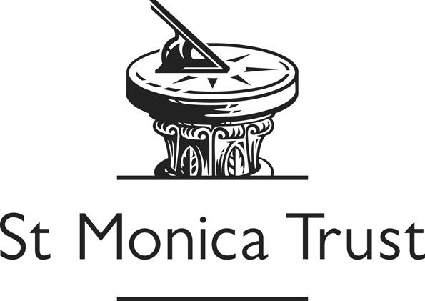

/tmp/in/input.doc

